RF Voltage Controlled Oscillator

Simulation:

Shown below is a RF Voltage Controlled Oscillator circuit. The oscillator chosen was a Colpitts configuration for its simplicity in design. It relies on a resonant LC circuit comprised of the inductor L1 and the capacitive voltage divider of C1 and C2. The varactor diode, D1, is reversed biased in order to introduce capacitance into the resonant circuit, thereby changing the resonant frequency as a function of its reverse bias voltage. The buffer amplifier has been added to mitigate loading effects.

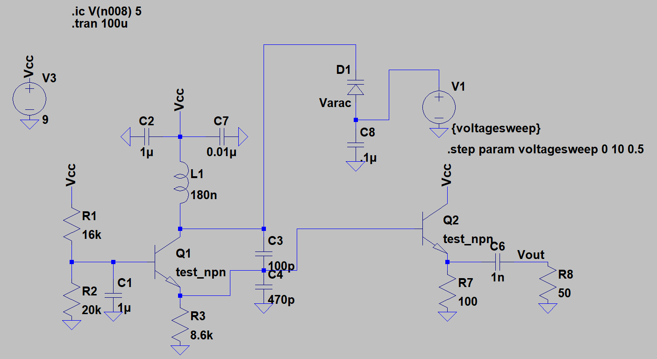

Buffer Amplifier

33.33 MHz Colpitts Oscillator

Tuning Voltage Subsection

*Figure 1: LTSpice Schematic*

To test the VCO, the tuning voltage (V1) was set to step from 0 V to 10 V by 0.5 V increments. The FFT of the resulting resonant frequencies are shown below.

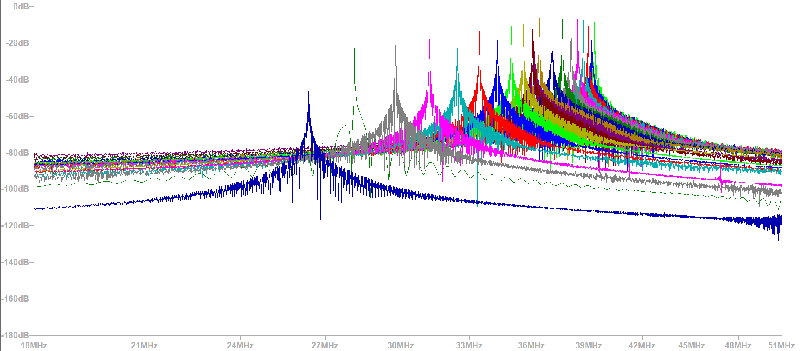

*Figure 2: Simulation Results*